CRM nErgy website – Navigation button
For the MAIN BUTTONS

Use the same design as the CRM ERP software but use a different color for the website.

CRM Features CRM Solutions Industries FAQs Ask My Zunme - VA SALES MORE
Virtual Assistant >>

Example on how the website Navigation should look
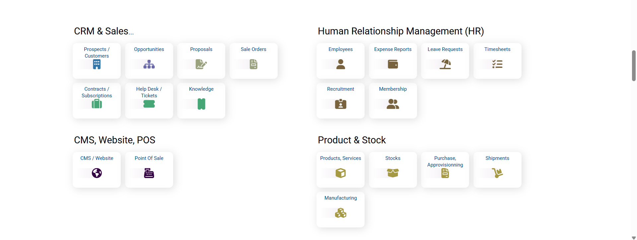
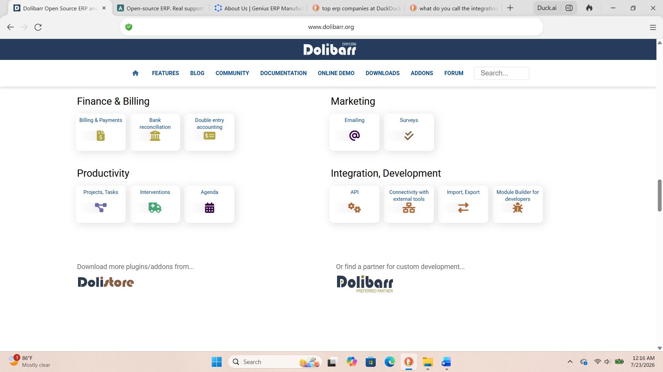

CRM Features
Industries Homepage
Affiliate Management
Analytic Accounting
Contact Management
Customer Service
Customizable Dashboards
Data Management
Financial Accounting
Inventory Management
Landing Page Creator
Lead Management
Manufacturing
Marketing Automation
Mobile Access
Payroll Processing
Project Management
Purchasing Management
Recruitment and Onboarding
Sales Management
Subscription Management
Supply Chain
Territory Management
White Label CRM

CRM Solutions
4 Types of CRM Software
Business CRM Software
Entrepreneurs
Third Party Integration

4 Types of CRM Software
Analytical CRM
Collaborative CRM
Operational CRM
Strategic CRM

Business CRM Software
Contact AI
Franchise
Influencers
Startup Business
Small to Mid – Size Biz

CRM for Entrepreneurs
Entrepreneurs Seeking Capital
Entrepreneurs Save Money
Software for Entrepreneurs

Third Party Integration
Third Party Integration CRM
Third Party Integration ERP
Third-Party CRM ERP Integration

Industries
Industries Homepage
Automotive
Construction
Consulting Firms
E-commerce
Education
Entertainment
Financial Services
Healthcare
Hospitality
Insurance
Manufacturing
Marketing
Media
Non-Profit
Professional Services
Real Estate
Retail
Software Development
Technology
Telecom
Travel
Unique Service Business

Fact and Questions – FAQs

CRM Features
(Display All Features Icon Buttons)

CRM Solutions
4 Types of CRM Software
Business CRM Software
CRM for Entrepreneurs
Third Party Integration

Industries
(Display All Features Icon Buttons)

What is My Zunme?

Sales

SALES - chat eBox

